**PIZZA SALES ANALYSIS - MySQL QUERIES**

1. Total Revenue

SELECT

SUM(total_price) AS Total_Revenue

FROM pizza_sales;

**OUTPUT**

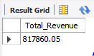

1. Average Order Price

SELECT

(SUM(total_price) / COUNT(DISTINCT order_id)) AS Avg_order_Value

FROM pizza_sales;

**OUTPUT**

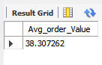

1. Total Pizzas Sold

SELECT

SUM(quantity) AS Total_pizza_sold

FROM pizza_sales;

**OUTPUT**

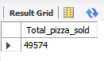

1. Total Orders

SELECT

COUNT(DISTINCT order_id) AS Total_Orders

FROM pizza_sales;

**OUTPUT**

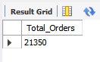

1. Average Pizzas Per Order

SELECT

CAST(CAST(SUM(quantity) AS DECIMAL(10,2)) /

CAST(COUNT(DISTINCT order_id) AS DECIMAL(10,2)) AS DECIMAL(10,2))

AS Avg_Pizzas_per_order

FROM pizza_sales;

**OUTPUT**

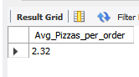

1. Hourly Trend for Total Pizzas Sold

SELECT

HOUR(order_time) AS order_hours,

SUM(quantity) AS total_pizzas_sold

FROM pizza_sales

GROUP BY HOUR(order_time)

ORDER BY HOUR(order_time);

**OUTPUT**

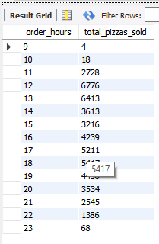

1. Weekly Trend for Orders

SELECT

WEEK(order_date,1) AS WeekNumber,

YEAR(order_date) AS Year,

COUNT(DISTINCT order_id) AS Total_orders

FROM pizza_sales

GROUP BY WEEK(order_date,1),YEAR(order_date)

ORDER BY Year, WeekNumber;

**OUTPUT**

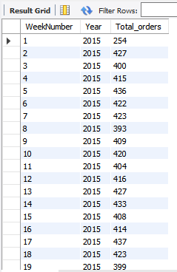

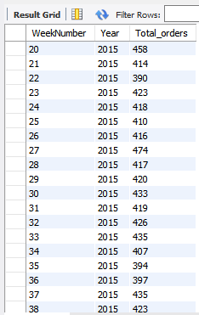

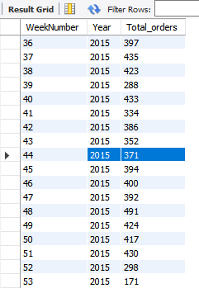

1. Percentage of Sales by Pizza Category

SELECT

pizza_category,

CAST(SUM(total_price) AS DECIMAL(10,2)) AS total_revenue,

CAST(SUM(total_price) * 100 / (SELECT SUM(total_price) FROM pizza_sales) AS DECIMAL(10,2)) AS PCT

FROM pizza_sales

GROUP BY pizza_category;

**OUTPUT**

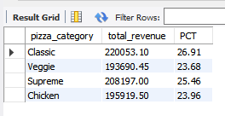

1. Percentage of Sales by Pizza Size

SELECT

pizza_size,

CAST(SUM(total_price) AS DECIMAL(10,2)) AS total_revenue,

CAST(SUM(total_price) * 100 / (SELECT SUM(total_price) FROM pizza_sales) AS DECIMAL(10,2)) AS PCT

FROM pizza_sales

GROUP BY pizza_size

ORDER BY pizza_size;

**OUTPUT**

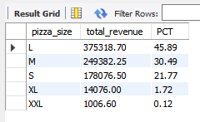

1. Total Pizzas Sold by Pizza Category

SELECT

pizza_category,

SUM(quantity) AS Total_Quantity_Sold

FROM pizza_sales

GROUP BY pizza_category

ORDER BY Total_Quantity_Sold DESC;

**OUTPUT**

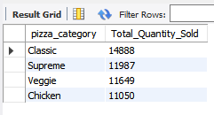

1. Top 5 Pizzas by Revenue

SELECT

pizza_name,

SUM(total_price) AS Total_Revenue

FROM pizza_sales

GROUP BY pizza_name

ORDER BY Total_Revenue DESC

LIMIT 5;

**OUTPUT**

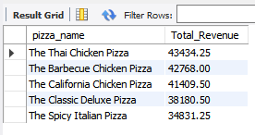

1. Bottom 5 Pizzas by Revenue

SELECT

pizza_name,

SUM(total_price) AS Total_Revenue

FROM pizza_sales

GROUP BY pizza_name

ORDER BY Total_Revenue ASC

LIMIT 5;

**OUTPUT**

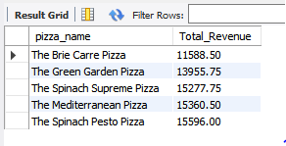

1. Top 5 Pizzas by Quantity

SELECT

pizza_name,

SUM(quantity) AS Total_Pizza_Sold

FROM pizza_sales

GROUP BY pizza_name

ORDER BY Total_Pizza_Sold DESC

LIMIT 5;

**OUTPUT**

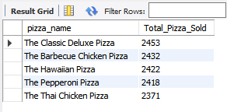

1. Bottom 5 Pizzas by Quantity

SELECT

pizza_name,

SUM(quantity) AS Total_Pizza_Sold

FROM pizza_sales

GROUP BY pizza_name

ORDER BY Total_Pizza_Sold ASC

LIMIT 5;

**OUTPUT**

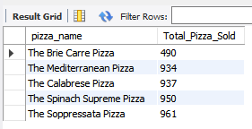

1. Top 5 Pizzas by Total Orders

SELECT

pizza_name,

COUNT(DISTINCT order_id) AS Total_Orders

FROM pizza_sales

GROUP BY pizza_name

ORDER BY Total_Orders DESC

LIMIT 5;

**OUTPUT**

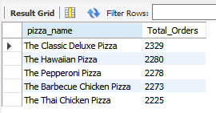

1. Bottom 5 Pizzas by Total Orders

SELECT

pizza_name,

COUNT(DISTINCT order_id) AS Total_Orders

FROM pizza_sales

GROUP BY pizza_name

ORDER BY Total_Orders ASC

LIMIT 5;

**OUTPUT**

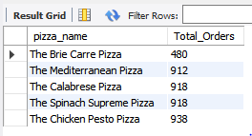

1. Modification is required in queries when a filer is applied

The application of filters requires using the ‘WHERE’ clause. Following is an example to demonstrate:

SELECT

pizza_name,

COUNT(DISTINCT order_id) AS Total_Orders

FROM pizza_sales

WHERE pizza_category = 'Classic'

GROUP BY pizza_name

ORDER BY Total_Orders ASC

LIMIT 5;